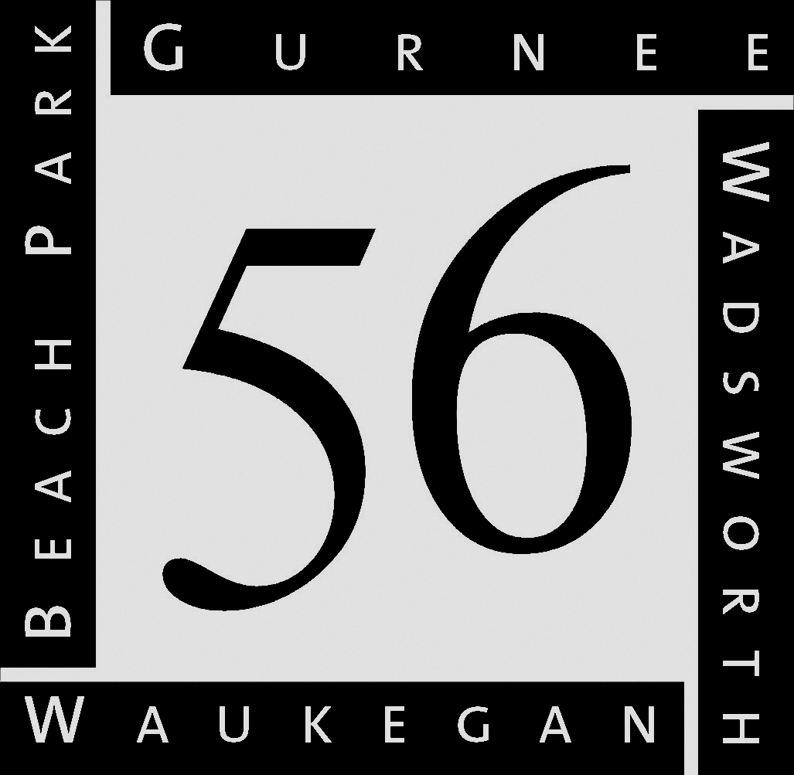
Education that inspires…Opportunities for all

GURNEE SCHOOL DISTRICT 56

3706 Florida Avenue • Gurnee, IL 60031 • 847-336-0800 • www.d56.org
Annual Medication Authorization Form
for Prescription and/or Over the Counter Non-Prescription Medications
School Year _________

Child’s Name: _____________________________ DOB: _________ Grade/Rm: _______ Teacher: ______________
Medication Taken at Home: _________________________________________________________________
Child’s Allergies: __________________________________________________________________________________
Attention Parents: Medication will not be administered without this form.
To be Completed by Parent or Legal Guardian

Authorization: Permission is hereby granted to Gurnee School District 56 to release information/to obtain information from the individual/organization as identified below for the purpose of the medication(s) requested. In signing this form, I understand the following provisions:
- I am under no obligation to sign.
- Failure to sign will mean that the information will not be requested or released. One consequence for refusing to release this information includes, but may not be limited to, a failure on the part of the receiving party to fully appreciate, or be aware of, the client’s/student’s pertinent history in planning and providing service/treatment.
- I have the right to revoke this authorization at any time by written request (except for information previously disclosed).
- I have the right to inspect and copy the information disclosed.
- This form authorizes the release of the information specified within one year from date of signature.
The medication needs to be sent to school in an appropriately labeled bottle by the pharmacy. Notify the school in writing if the medication is discontinued. Obtain a written doctors order if the medication dosage is changed. A parent must bring the medication to the school nurse. For the safety of your child, the School District retains the right to reject the administration of medication if compliance with these guidelines is not followed. I have read and understand the above medication authorization.
I give permission for my child to receive the medication(s) by assigned school personnel as directed by the physician.

Parent/Guardian Signature:_______________________ Print Name: _____________________ Date: ______________
Work Phone #: ___________________ Home Phone #: ___________________ Cell Phone #: ____________________

--------------------------------------------------------------------------------------------------------------------------------------------------------------
To be Completed by Physician Only

Attention Physician: Your signature indicates that these medications are necessary during school attendance.

Medication given for diagnosis of: 1. _________________ 2. _________________ 3. _____________________

Intended effect of medication: 1. _________________ 2. _________________ 3. _____________________

Medication/Dosage/Frequency | Time and Dose to be given at School | Duration/End Date | Possible Side Effects Anticipated
1.

2.

3.

Signature of Physician: _________________________________________________ Date: ___________________
Printed Name of Physician: _________________________________________________________________________
Address: ________________________________ City/State: _____________________ Zip: _____________________
Telephone: ___________________________________ Fax: ______________________________________________

