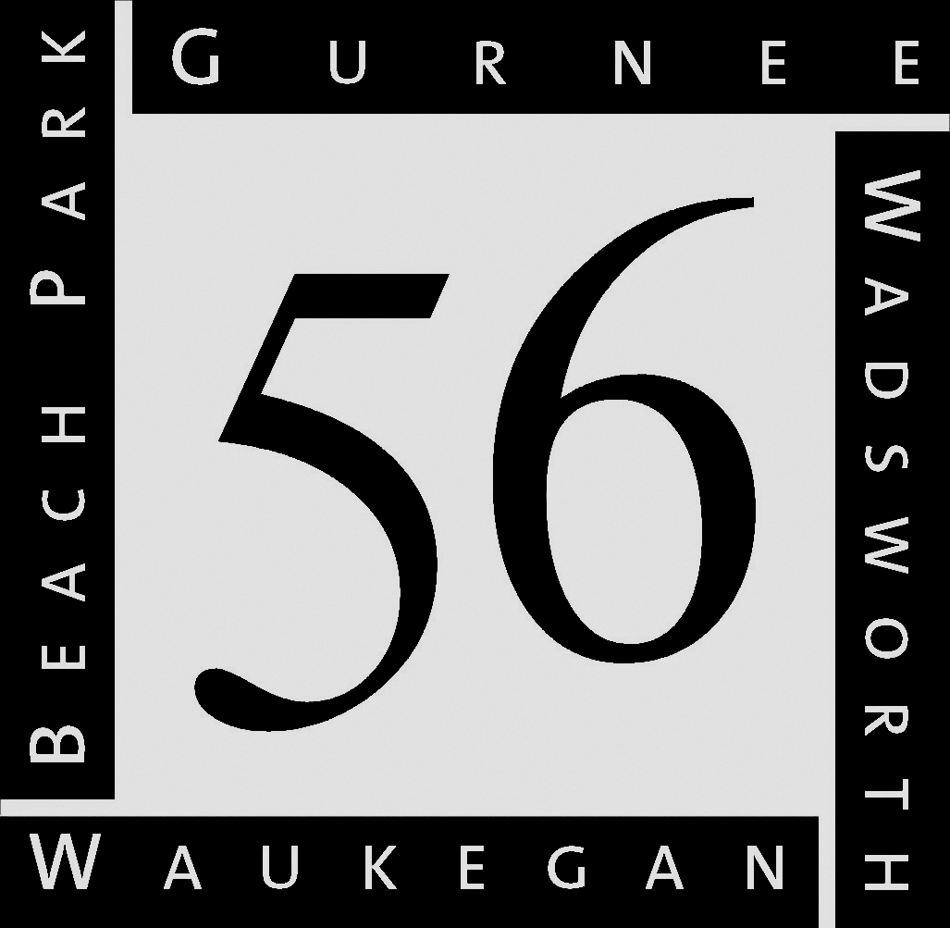
Return to School Nurse ASAP or within two weeks of receiving. Thank you
Education that inspires…Opportunities for all

GURNEE SCHOOL DISTRICT 56

3706 Florida Avenue • Gurnee, IL 60031 • 847-336-0800 • www.d56.org

Medical Review

Please complete the following information regarding your child. Your answers will provide us with baseline information and the necessary data for problem identification and a working knowledge of your child as a unique individual. Thank you for your cooperation. Today’s Date:

PLEASE RETURN THIS FORM TO YOUR CHILD’S SCHOOL OFFICE WITHIN ONE WEEK.

CHILD’S NAME: BIRTHDATE: AGE:
GRADE: TEACHER:

Name of Adult completing this form:
Relationship to above named child:
Birth Parent Foster Parent Adoptive Parent Guardian

To the best of your ability, please answer all of the questions, even if you feel they do not apply. Please ask the person who gave you this form for help if there is something you do not understand.

What are your main concerns?

What is the best phone number to reach you?
What is the best time of day to reach you?

Do you prefer to be reached by email? No Yes, email address

Parental Information
Mother/Guardian’s Name Age
Occupation Employer Military No Yes
Highest grade level completed?
Father/Guardian’s Name Age
Occupation Employer Military No Yes
Highest grade level completed?
Does this child have other parents/stepparent(s)? No Yes, if yes please provide the following information.
Name Relationship to this child
Name Relationship to this child
Primary Caregivers
With what adult(s) does this child live? How long in this current living situation
Who cares for this child when caregivers are gone?
How many hours per day is this child in a child-care setting?

Pregnancy History Prenatal History is unknown

Mother’s age during this pregnancy Mother’s occupation during this pregnancy
Mother’s overall health during pregnancy: Excellent Good Fair Poor, explain
Father’s age during this pregnancy Father’s occupation during this pregnancy

YES | NO | Pregnancy questions regarding student’s birth mother | Notes
 | Was this a planned pregnancy?
 | Was there prenatal care?
 | Were prenatal vitamins taken?
 | Was her diet healthy during pregnancy?
 | Were alcohol or take illegal drugs taken during pregnancy? | What kind:
 | Were cigarettes smoked during pregnancy?
 | Were prescription medications taken during pregnancy? | What kind:
 | Were over the counter medications taken during the pregnancy? | What kind:
 | Was caffeine taken (coffee/soda/tea)?
 | Medical Diagnoses during pregnancy
 | High Blood Pressure/Preeclampsia
 | Gestational Diabetes
 | Weight gain during pregnancy: 0-20# 21-30# 31-more#
 | Injury or serious illness
 | Bleeding/spotting (when/how long)
 | Emotional Stress
 | Abnormal lab work (low hemoglobin, low Vitamin D, others)

Birth History Birth History is unknown
Due Date Gestational Age at time of birth (weeks) Birth Weight
Was the babyearly late on time Was your baby considered premature? Yes, how many weeks early
Vaginal Birth C-section Forceps or Vacuum Medications for pain
Hospital Birth Home Birth Other Passed Newborn Hearing Screening: No Yes
How long did baby stay in hospital? How long did mother stay in hospital ?
Was mother sick with infection or fever during the delivery or shortly after? No Yes, explain
If the baby stayed longer then the mother, why?
APGAR scores (if known)

Did the baby have any of the following problems or needs?
YES | Birth Issues
 | Oxygen needed? How long?
 | Intubation
 | Heart issues
 | Jaundice
 | Treated with bilirubin (phototherapy) lights? How long?
 | Any medications used? List:
 | Any emergency surgeries or procedures at birth or shortly after? List:
 | Any scans (MRI, CT, X-ray) or labs required at birth? List: ________________________________________________________________________________________________
Any other concerns or comments regarding your child’s birth

First Year of Life History is unknown
Would you say your child’s health in the first year of life was Excellent Very Good Good
Fair Poor, explain

Health Problems in the first year of life
YES | NO | Feeding problems (poor sucking, vomiting, choking…) explain,
 |  | Sleeping problems
 |  | Infections (high fever…)
 |  | Seizures (with or without fever)
 |  | Birth defects
 |  | Special tests or medications needed. Explain,
 |  | Special equipment or treatments needed at home, explain
 |  | Was Physical Therapy or any other type of therapy needed? Explain
Any other issues or concerns in the first year of life?

Developmental Milestones, please check yes if your child met these milestones in the specified time frame
YES | NO | Milestones accomplished | If NO, age accomplished
 |  | Rolled over by age 7 months
 |  | Responded to noises/smiles by age 7 months
 |  | Made babbling sounds by age 7 months
 |  | Crawled by age 12 months
 |  | Stood without support by age 12 months
 |  | Spoke a single word by age 12 months
 |  | Used gestures such as waving bye-bye by 12 months
 |  | Walked without help by age 18 months
 |  | Spoke at least 6 words by age 18 months
 |  | Used a cup by age 24 months
 |  | Scribbles by age 24 months
 |  | Followed simple instructions by age 24 months
 |  | Spoke simple sentences by age 24 months
 |  | Plays with other children by age 36 months
 |  | Socialized with non-family members by age 36 months
 |  | Made eye contact by age 36 months
 |  | Able to throw and kick a ball by age 36 months
 |  | Speech easily understood by strangers by age 36 months
 |  | Able to name familiar objects such as shoes by age 36 months
History is unknown
Were any of your child’s skills/developmental milestones lost after 24 months of age? No Yes, explain

Early Childhood Development | Age
Ride a bicycle
Catch a ball
Tie shoe laces
Use a scissors
Write name
Toilet trained daytime
Toilet trained night time

Illness History Check all of those that apply, please give a brief description and include student’s age at time of condition.
Yes|No | Illness/Condition | Description | Age | Yes|NO | Illness/Condition | Description | Age
 | Strep Throat |  |  |  | Tonsillitis
 | Chicken Pox |  |  |  | Measles/German Measles/Mumps
 | Tuberculosis |  |  |  | Asthma
 | Bronchitis/Reactive Airway Disease |  |  |  | Heart Condition/Murmur
 | Stomach/Intestinal Problems |  |  |  | Constipation
 | Celiac Disease |  |  |  | Frequent Stomach Aches
 | Diabetes |  |  |  | Genetic Condition
 | Kidney/Urinary Problems |  |  |  | Wetting/Soiling Problems
 | Allergies |  |  |  | Skin Condition
 | Life-Threatening Allergies |  |  |  | Epi Pen for treating life threatening allergies
 | Fever above 104 |  |  |  | Seizures/Convulsion/Tics/Twitches
 | Growth/Development Concerns |  |  |  | Taking Growth Hormones
 | Cancer |  |  |  | Blood Disorder
 | Surgery/Hospitalizations |  |  |  | Heart/Cardiac Condition
 | Hearing Problems |  |  |  | Hearing Aid/Sound Device
 | Ear Tubes/Ear Surgery |  |  |  | Cochlear Implant
 | Frequent Colds |  |  |  | Frequent Ear Infections
 | Eye Problems |  |  |  | Glasses/Contact lenses
 | Broken Bone/Fracture |  |  |  | Orthotic Devices/Splints
 | Muscle/ Joint Problems |  |  |  | Scoliosis
 | Accident/Fall/Injury |  |  |  | Activity Limitations
 | ADD/ADHD/Hyper-Activity/Focus Problems |  |  |  | Anxiety/Depression
 | Obsessive/Compulsive Symptoms |  |  |  | Oppositional/Defiant Symptoms
 | Autism/PDD/Asperger’s |  |  |  | Unusual Fears
 | Physically Abused |  |  |  | Sexually Abused
Please give details here:
Please make note of any other medical issues or concerns:
Medical Diagnoses:
Date diagnosed:
Physician’s name:

Physician History (doctors your child has seen)
 | Type of Physician | Physician’s Name/Reason for visit/Frequency of visits | Age at time of visit(s)
 | Pediatrician
 | Allergist
 | Cardiologist
 | Ear/Nose/Throat Specialist
 | Endocrinologist
 | Gastroenterologist
 | Neurologist
 | Ophthalmologist/Optometrist (Eye Doctor)
 | Orthopedic (Bone Doctor)
 | Psychiatrist/Psychologist

Has your child received any therapies: Physical Occupational Speech At what age?
Your child is: Right Handed Left Handed Both

Student Lifestyle
Do you think your child’s health is: Excellent/Very healthy Usually healthy/Occasionally ill Sick more frequently than other children Sick “all the time”

How does your child perceive his/her health, is it similar to your perception?
Does your child’s teacher ever express concerns to you regarding your child’s health, illnesses, or absenteeism? If so, please explain:
Sleeps from pm until am
Sleeps through the night | Yes | No
How long does it take your child to fall asleep?
How much screen time (TV and electronics) is your child allowed each day?
Does the student have access to electronics in his/her bedroom throughout the night? | Yes | No

Medications, please list name, dosage and time taken:

List Vitamins and/or herbal supplements:
Nutrition
Does your child eat a well-balanced diet? No Yes, if no explain
Is your child a picky eater? Yes No
Is your child a vegetarian or vegan? Yes No
Does your child have any dietary restrictions? Yes No, explain
Does your child drink caffeine? ☐ Yes, how much and how often
Is your child exposed to cigarette smoke? Yes No,
Are there pets in the home? Yes No list pets,
Briefly describe a typical day for your child:
Is your child able to perform all activities of daily living? (dress themselves, zippers, brush teeth…) Yes No, if no please explain
Please make note of any concerns not mentioned above:

Family Information
Has this child ever experienced parental separations, divorces, or death of a family member? No Yes
If yes, when? What was the child’s age at the time?
Please describe the circumstances:
Siblings: Please list all siblings, and any other children living with the family.
Age | Name of Brother/Sister
Has anyone in the family had any of the following? If yes please specify relationship to child in space provided.
YES|NO | Disease/Illness/Condition | Relation to student | YES|NO | Disease/Illness/Condition | Relation to student
 | ADD/ADHD |  |  | LEARNING DISABILITY
 | AUTISM/PDD/ASPERGER |  |  | MENTAL ILLNESS/ANXIETY/DEPRESSION
 | ALCOHOL/DRUG ABUSE |  |  | NEUROLOGICAL CONDITION
 | BEHAVIOR DISORDER |  |  | OTHER GENETIC CONDITION
 | CANCER |  |  | SEIZURES/EPILEPSY/TWITCHING/TICS
 | DIABETES |  |  | SPECIAL EDUCATION
 | HEART DISEASE |  |  | SPEECH OR LANGUAGE PROBLEM
IF YES, PLEASE EXPLAIN HERE
Please note anything else you would like to share about your child’s health history here:

Thank you for your time.

